|  |  |  |  |
| --- | --- | --- | --- |
| 1 | | 30,720.0 | |
| NUMERO DE FRONTERAS | | ENERGIA AGREGADA | |
|  | | | |
| SI | | 31-12-2020 | |
| CONTRATO | | VENCIMIENTO CONTRATO | |
|  | | | |
| 325,351,825 | 119 | | 12,497,846 |
| INGRESO 2019 | DÍAS CERTIFICADOS 2019 | | ENERGIA RESPALDADA 2019 |
|  | | | |
| 511,341,016 | 198 | | 18,510,349 |
| INGRESO 2020 | DÍAS CERTIFICADOS 2020 | | ENERGIA RESPALDADA 2020 |
|  | | | |
| 83,687,113 | 119 | | 3,654,592 |
| INGRESO 2021 | DÍAS CERTIFICADOS 2021 | | ENERGIA RESPALDADA 2021 |

|  |
| --- |
| **COLOMBINA LA PAILA**  USUARIO |

|  |
| --- |
| **Mateo Porras**  Ejecutivo de cuenta |

|  |
| --- |
| **Francisco Pizarro / Gerente de proyectos & Administración Energética / fpizarro@colombina.com**  Primera fecha: PUNTO FOCAL |

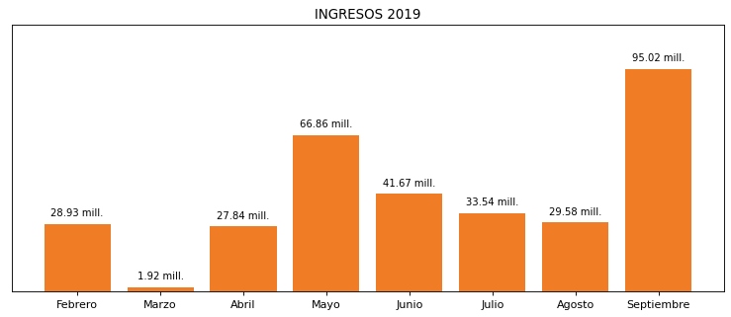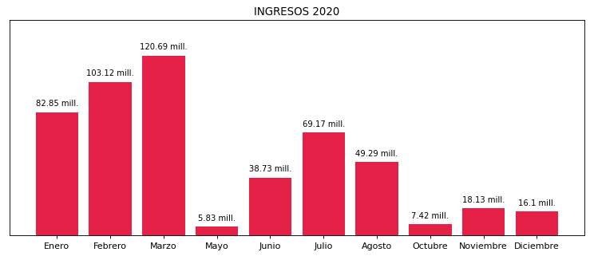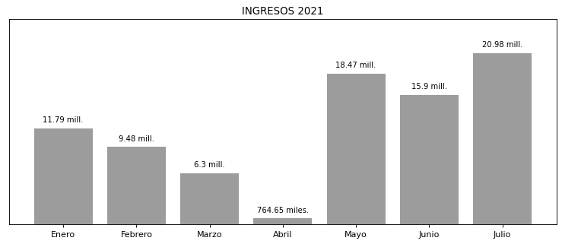

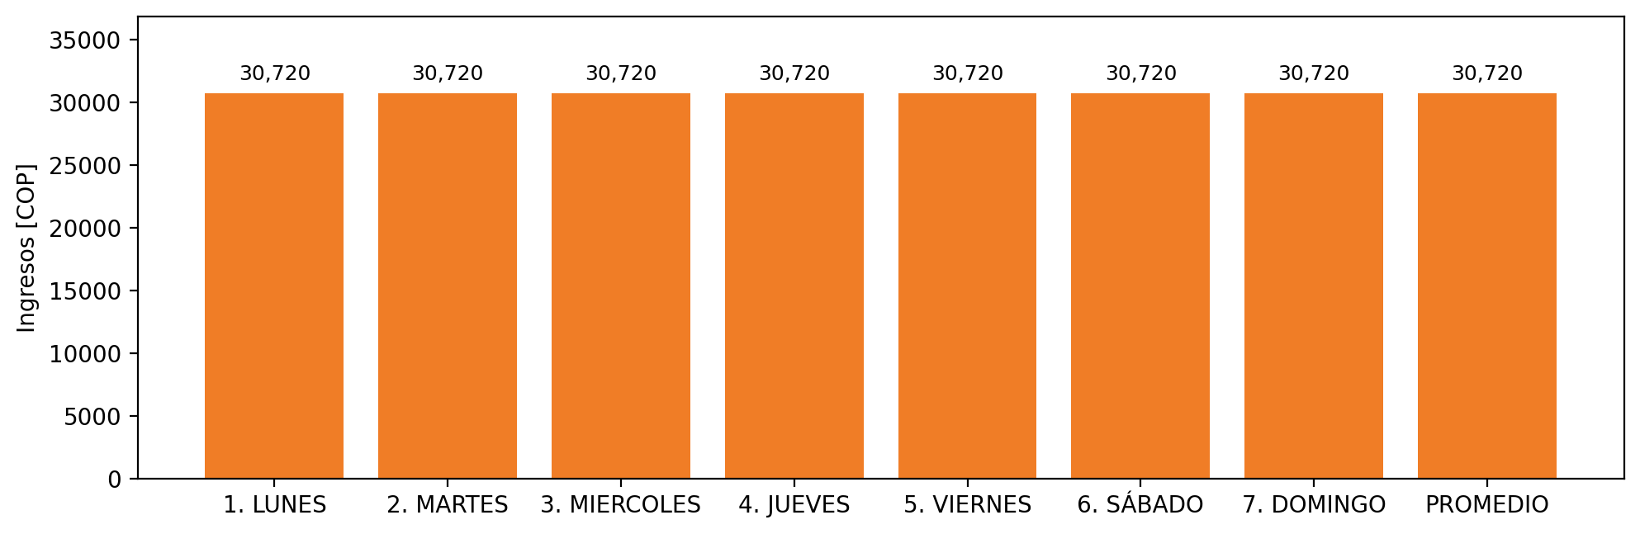

|  |  |  |  |  |  |  |  |  |  |
| --- | --- | --- | --- | --- | --- | --- | --- | --- | --- |
| **FRONTERA COMERCIAL** | **TIPO DDV** | **COD SIC** | **PREDIO** | **PROMEDIO** | **MARGEN** | **ÚLTIMA DESCONEXION** | **DÍAS CERTIFICADOS** | **ACTUALIZACION** | **PROXIMA PRUEBA DDV** |
| COLOMBINA S.A. PLANTA LA PAILA | Frt35803 | Frt00754 | Prd01510 | 30,720 | NO APLICA | 2021-10-17 | 0.0 | 2026-04-15 | 2022-02-21 |